Electric Vehicle Ecosystem Analytics: Trends, Range, and Regional Insights
Python (Google Colab) & Power BI Desktop

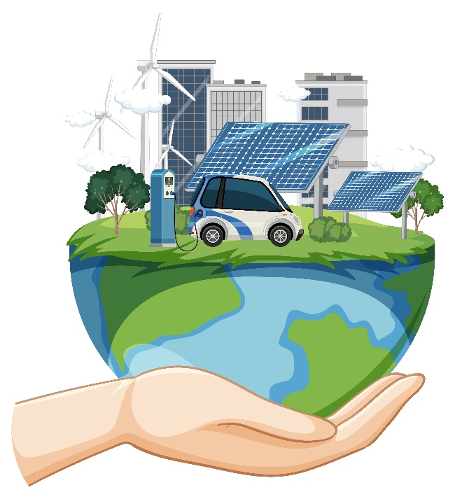

July 7, 2026
Jagan raj m
Aspiring Data Analyst

Electric Vehicle Ecosystem Analytics: Trends, Range, and Regional Insights

Project Summary:
- Data Analysis: Collected, cleaned, and analyzed EV registration data using Python (Pandas, NumPy) to identify trends in vehicle types, brands, electric range, and regional adoption.
- Dashboard Development: Built an interactive Power BI dashboard with KPIs, charts, maps, and slicers to visualize EV performance, model year trends, CAFV eligibility, and geographic distribution.
- Business Insights: Delivered actionable insights and recommendations by identifying leading EV brands, growth trends, and regional patterns to support data-driven decision-making and sustainable transportation planning.
Tools And Technology Involved:
- Python (Google Colab): Data cleaning, preprocessing, and EDA.
- Pandas & NumPy: Data manipulation and analysis.
- Matplotlib & Seaborn: Data visualization.
- Power BI Desktop: Interactive dashboard development.
- Power Query & DAX: Data transformation and KPI calculations.
- Microsoft Excel: Data validation and CSV management.
Python (Google Colab):
Data Collection:
- Collected a comprehensive Electric Vehicle (EV) registration dataset from a public data source containing vehicle make, model, model year, electric vehicle type, electric range, CAFV eligibility, electric utility, county, city, state, and vehicle location details. The dataset consists of approximately 287,000+ records and 17 columns, providing a rich source for analyzing EV adoption trends, manufacturer performance, and regional distribution.
- Validated and prepared the collected data by checking for missing values, duplicate records, and inconsistent data types before performing exploratory data analysis and building interactive Power BI dashboards.

Data Imputation:
- Categorical column imputation was performed by replacing missing values in the Vehicle Location column with the mode (most frequently occurring location) to maintain data consistency and preserve geographical information for location-based analysis and visualization.
Visualization:

Univariate Analysis
- The count plot shows the number of electric vehicles for each model year. It indicates that electric vehicle registrations have increased in recent years, showing the growing popularity of EVs.
- The pie chart shows the percentage distribution of the Top 15 electric vehicle brands in the dataset. It helps identify the brands with the largest market share, indicating which manufacturers are the most popular among EV owners.
- The histogram shows how electric vehicle registrations are distributed across different counties. It helps identify which counties have a higher or lower number of registered electric vehicles.

Bivariate Analysis
- The bar plot compares the average electric driving range of different EV manufacturers. It shows that some vehicle brands offer a higher electric range than others. This helps identify manufacturers with better battery performance and longer driving capability.
- The box plot compares the electric driving range across different CAFV eligibility categories. It shows that electric range varies among the eligibility groups, with some groups having higher median ranges than others. The plot also highlights the presence of outliers, indicating vehicles with unusually high or low electric ranges.
- The violin plot shows the distribution of electric driving range for each CAFV eligibility category. It helps compare how electric ranges are spread within different eligibility groups. The wider sections of the violin indicate where more vehicles have similar electric range values.

Multivariate Analysis
- The Pair plot shows the relationships between all the numerical variables in the dataset. It helps identify patterns, trends, and possible correlations between different features. The diagonal plots show the distribution of each numerical variable individually. The scatter plots help detect clusters, outliers, and any positive or negative relationships between variables. Overall, the pair plot provides a quick overview of the dataset's numerical characteristics.
- The correlation heatmap shows the strength and direction of the relationship between numerical variables in the dataset. Darker colors indicate stronger positive or negative correlations, while lighter colors indicate weaker relationships. It helps identify which variables are closely related and which have little or no correlation. This visualization makes it easier to understand feature relationships and supports better data analysis and decision-making.
- The 3D scatter plot shows the relationship between Model Year, Electric Range, and Legislative District. It helps visualize how electric vehicle range varies across different model years and districts. The color of each point represents the electric range, making it easy to identify vehicles with higher or lower ranges. The plot also helps detect patterns, clusters, and variations in the distribution of electric vehicles across legislative districts.
Power BI Desktop
Import Cleaned Data into Power BI:
- Imported the cleaned Electric Vehicle (EV) dataset generated from Python into Power BI Desktop in CSV format.
- Validated data types, established data relationships, and formatted numerical fields to ensure accurate calculations and interactive reporting.
- Designed dynamic dashboards using KPI cards, charts, maps, and slicers to transform raw EV registration data into meaningful business insights.

Interactive Main Dashboard Charts
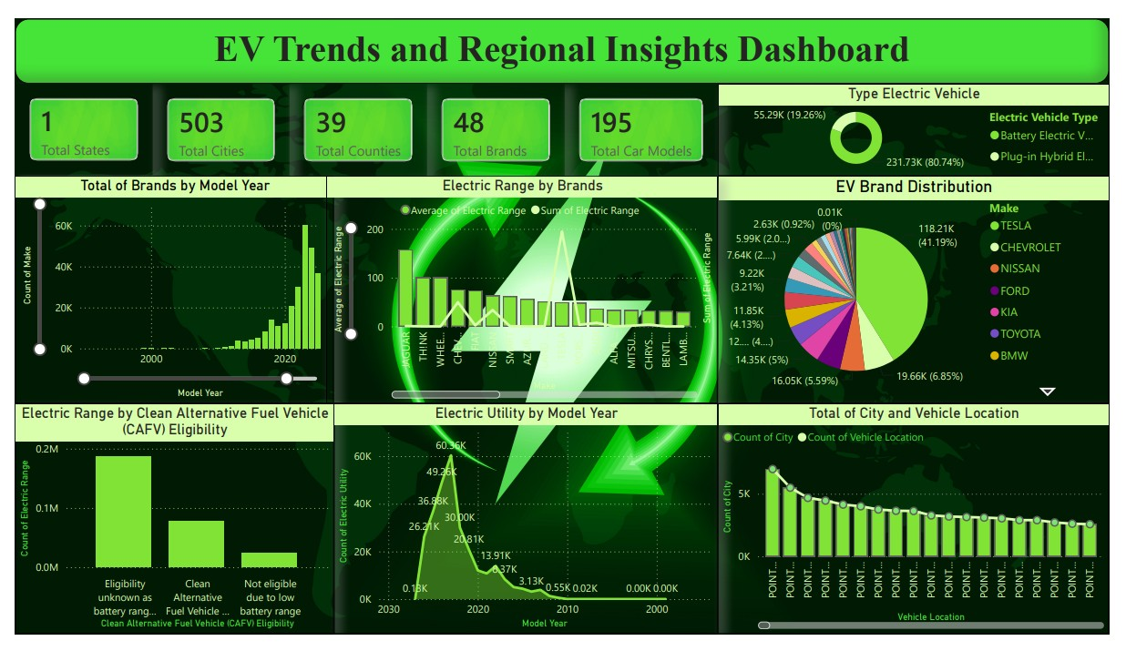
Insights from Main Dashboard Charts
- KPI Cards show that the dataset includes 48 EV brands, 195 models, 503 cities, and 39 counties, providing comprehensive coverage of the electric vehicle market.
- EV Type Distribution indicates that Battery Electric Vehicles (BEVs) account for over 80% of total registrations, demonstrating a strong consumer preference for fully electric vehicles over Plug-in Hybrid Electric Vehicles (PHEVs).
- Brand Distribution reveals that Tesla is the market leader in EV registrations, followed by Chevrolet, Nissan, Ford, Kia, and Toyota, highlighting the competitive landscape of major EV manufacturers.
- Model Year Trend shows a significant increase in EV registrations after 2020, reflecting the rapid growth of the EV market driven by technological advancements and government incentives.
- Electric Range by Brand highlights that manufacturers such as Tesla, Jaguar, Porsche, and BMW offer higher average electric ranges, indicating superior battery performance and innovation.
- CAFV Eligibility Analysis demonstrates that a large proportion of registered vehicles are CAFV eligible, supporting the adoption of environmentally friendly transportation and clean energy initiatives.
- Geographic Distribution identifies higher EV adoption in urban regions, emphasizing the need for continued expansion of charging infrastructure in densely populated areas.
- Vehicle Location Analysis reveals that EV registrations are concentrated in specific cities and counties, helping stakeholders identify high-demand regions.
- Electric Utility Trend shows increasing EV adoption across utility service areas, indicating growing electricity demand and the importance of future energy infrastructure planning.
Insights from Dashboard – Brands & Types
- Tesla dominates EV registrations, followed by Chevrolet, Nissan, Ford, and Kia, indicating strong market leadership.
- Battery Electric Vehicles (BEVs) account for the majority of registrations, while Plug-in Hybrid Electric Vehicles (PHEVs) represent a smaller market share.
- The dashboard highlights increasing consumer preference for fully electric vehicles over hybrid alternatives.
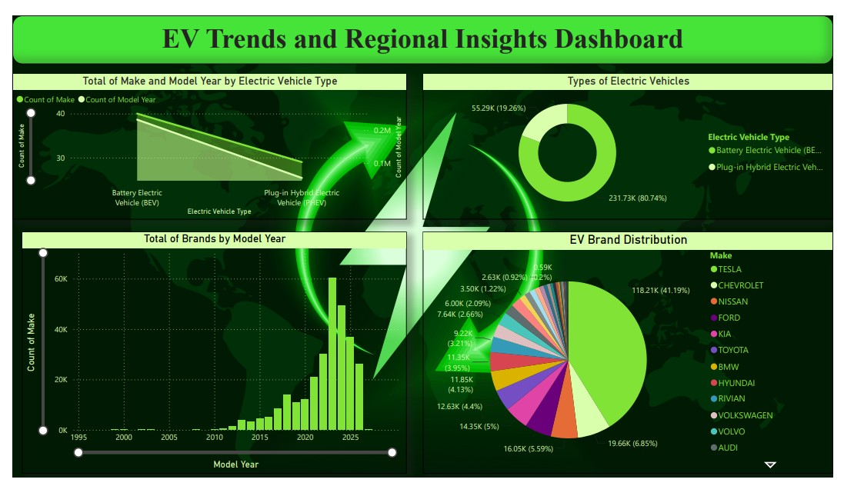

Insights from Dashboard – Model Year & CAFV
- EV registrations have grown significantly after 2020, demonstrating the rapid expansion of the electric vehicle market.
- Most registered vehicles are CAFV Eligible, reflecting increased adoption of environmentally friendly vehicles.
- The combination of newer model years and CAFV incentives has contributed to higher EV adoption.
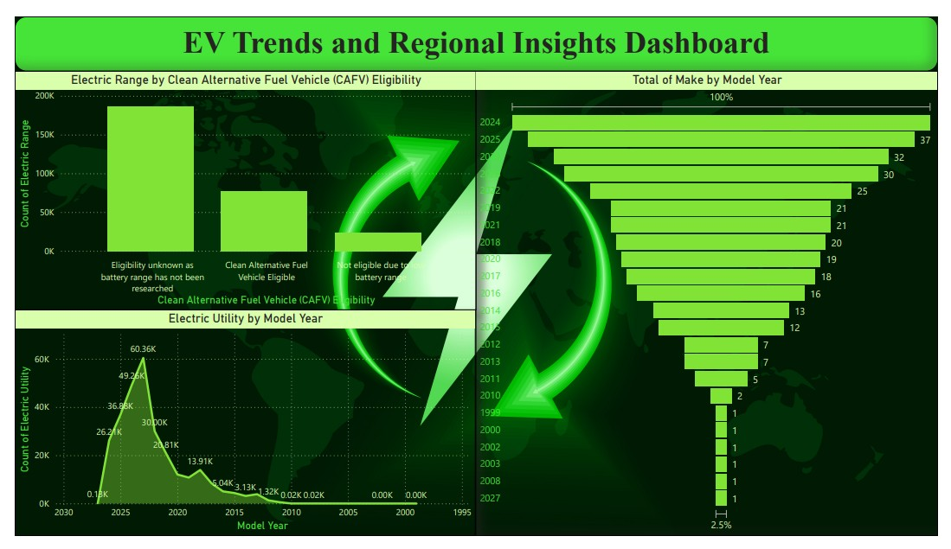
Insights from Dashboard – Location & Range
- Urban cities and counties show the highest concentration of EV registrations, indicating greater adoption in metropolitan areas.
- Premium manufacturers such as Tesla, Jaguar, and Porsche provide higher average electric ranges.
- The dashboard helps identify regions where long-range EVs are more commonly used and where charging infrastructure demand is highest.

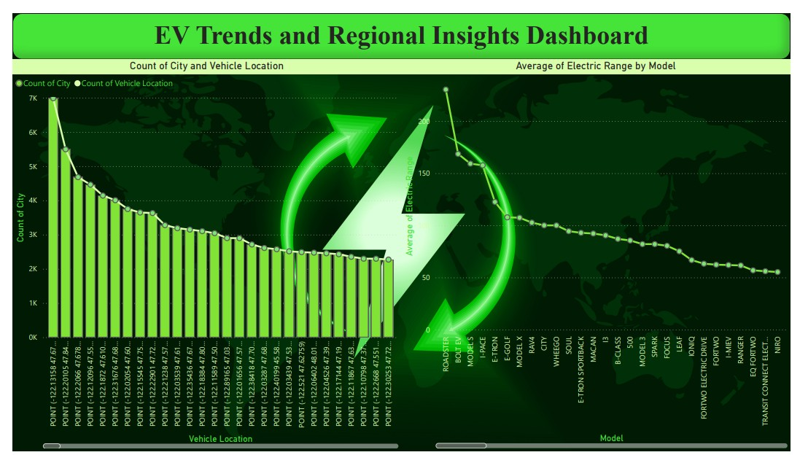
Insights from Dashboard – States & Brands
- The state-level analysis shows that EV registrations are concentrated among a few leading manufacturers.
- Tesla maintains the highest market share across the state, while Chevrolet, Nissan, Ford, and other brands continue to contribute significantly.
- Brand-wise analysis enables comparison of manufacturer performance across different regions.
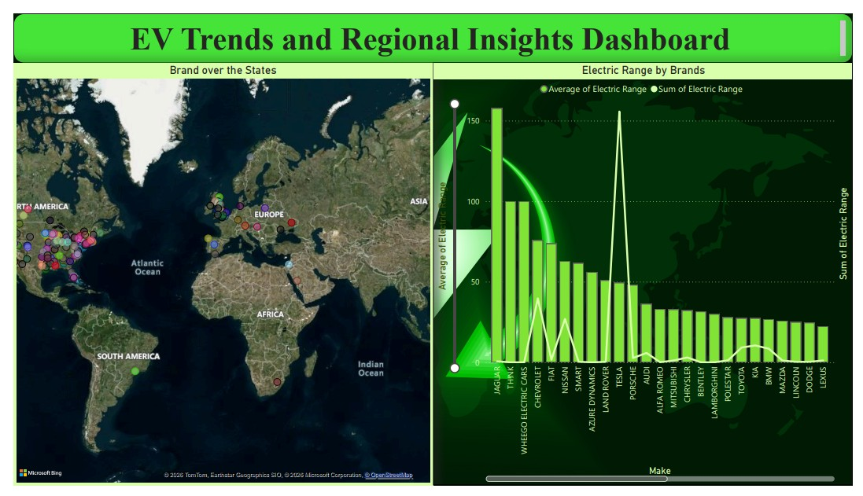

Insights from Dashboard – Tree Map of Brand Produced
- The treemap clearly visualizes the contribution of each manufacturer based on total EV registrations.
- Tesla occupies the largest area, indicating the highest production and registration share among all brands.
- Other manufacturers contribute smaller but significant portions, highlighting the competitive diversity of the EV market and helping identify leading and emerging brands.
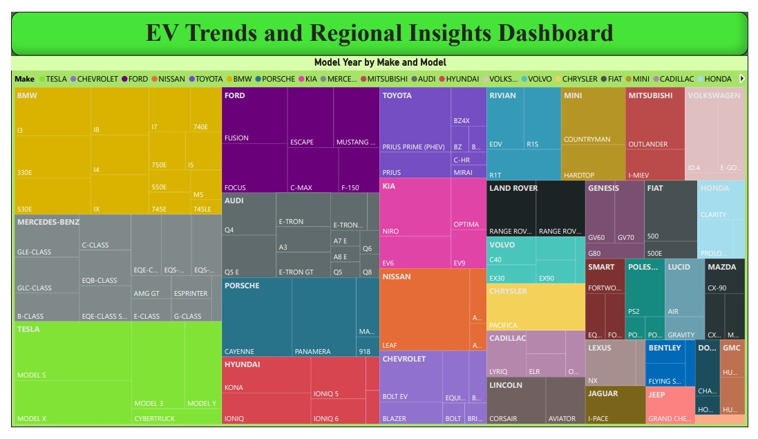
Final Summary & Business Recommendations
- The Electric Vehicle Ecosystem Analytics project successfully analyzed EV registration data using Python and Power BI, converting raw data into meaningful business insights through data cleaning, preprocessing, exploratory data analysis (EDA), and interactive dashboards.
- The analysis shows that the EV market is experiencing steady growth, with Battery Electric Vehicles (BEVs) accounting for the majority of registrations, indicating a strong shift toward sustainable transportation.
- Tesla leads the EV market, followed by manufacturers such as Chevrolet, Nissan, Ford, Kia, Toyota, and BMW, demonstrating a competitive and expanding electric vehicle industry.
- The Model Year Trend reveals a significant increase in EV registrations after 2020, driven by technological advancements, government incentives, and growing environmental awareness.
- Electric Range Analysis highlights that premium manufacturers provide higher driving ranges, while CAFV Eligibility Analysis indicates that a large share of vehicles qualify for clean-energy incentive programs.
- Geographic and Vehicle Location Analysis identify urban regions as major EV adoption hubs, emphasizing the need for expanding charging infrastructure and improving utility support.
- The interactive Power BI dashboards enable stakeholders to monitor EV trends, manufacturer performance, geographic distribution, and market growth, supporting data-driven business decisions.
Business Recommendations
- Expand public charging infrastructure in high-demand and emerging regions.
- Continue promoting CAFV-eligible vehicles through government incentives and awareness programs.
- Invest in battery technology to improve driving range, charging speed, and overall vehicle performance.
- Strengthen collaboration between manufacturers, utility providers, and policymakers to support sustainable transportation.
- Support renewable energy integration for EV charging infrastructure to reduce carbon emissions and improve energy sustainability.
Future Scope
- Integrate Machine Learning models to predict EV adoption trends, forecast electric vehicle demand, estimate battery performance, and identify future market growth, enabling proactive business planning and policy decisions.
- Enhance EV ecosystem analytics by integrating additional datasets such as charging infrastructure, traffic patterns, weather conditions, energy consumption, and customer usage behavior to gain deeper insights into EV performance and adoption.
- Leverage advanced analytics to segment regions based on EV adoption levels, charging infrastructure availability, and market potential, enabling governments, utility providers, and manufacturers to make data-driven decisions for infrastructure expansion and sustainable transportation planning.
Conclusion
The Electric Vehicle Ecosystem Analytics project successfully analyzed EV registration data using Python and Power BI to uncover key trends in EV adoption, brand performance, electric range, and regional distribution. The interactive dashboards provide valuable business insights that support data-driven decision-making and contribute to sustainable transportation planning. The analysis highlighted key trends in EV adoption, manufacturer performance, electric range, CAFV eligibility, and regional distribution, enabling data-driven decision-making.

